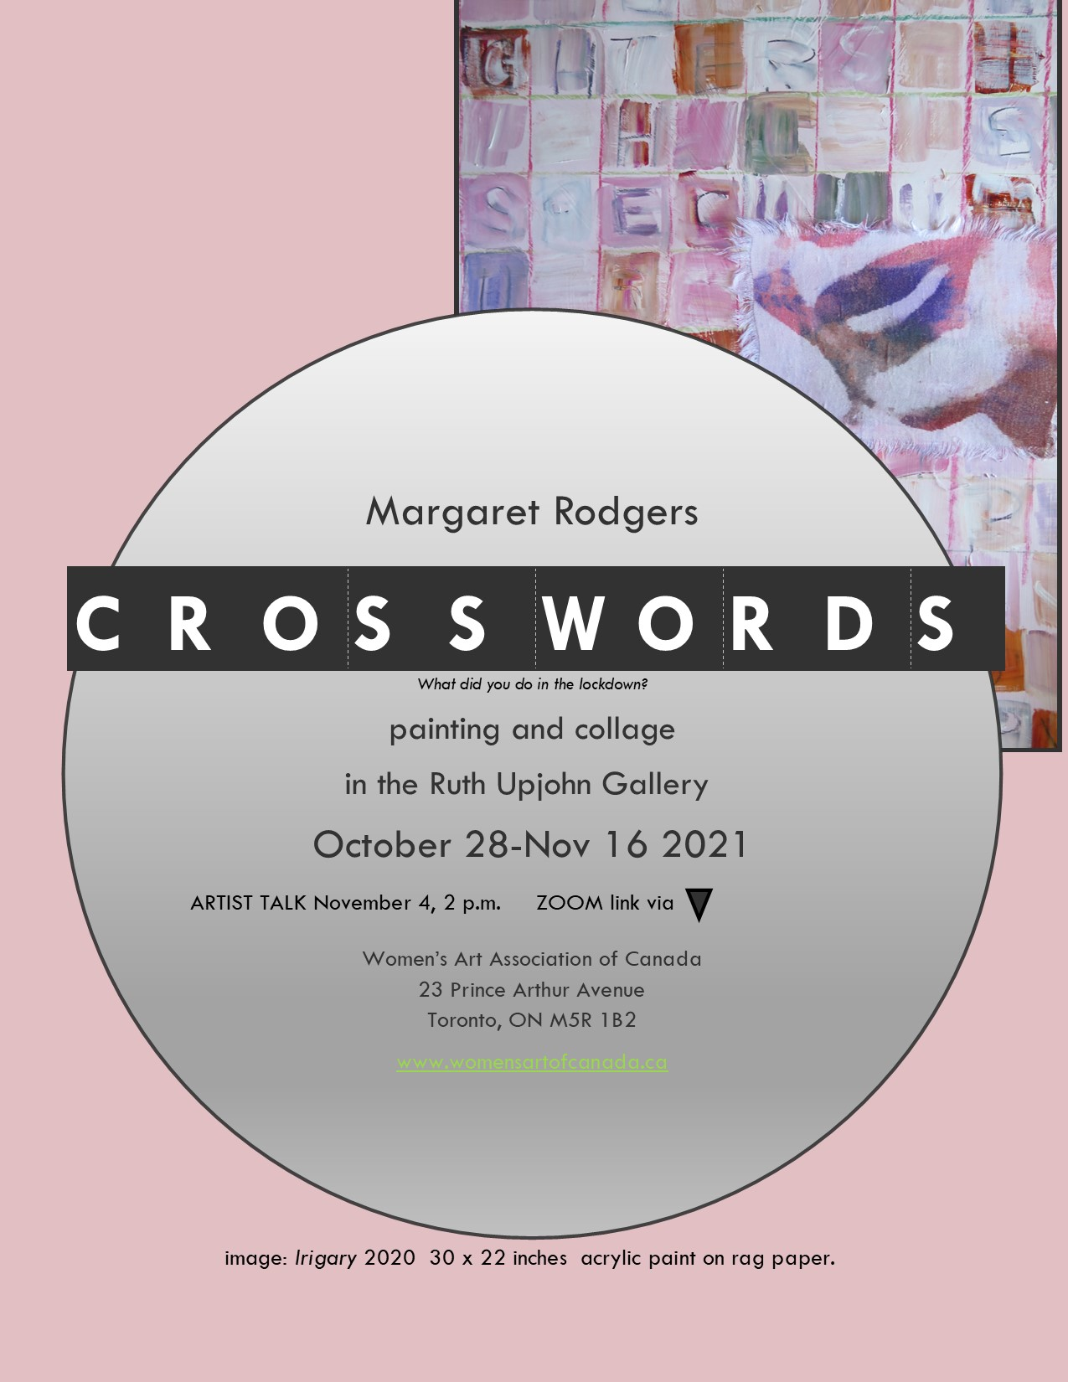

LIST OF WORKS
Each piece is 30 x 22 inches on rag paper unless otherwise indicated
Unframed works : $400
Framed: $650

- Marketplace of Ideas. Acrylic framed

- Cixous. Acrylic/linen

- Julia. Acrylic/linen

- Luce. Acrylic/linen

- Simone. Acrylic/linen

- CLIMATE. Acrylic/linen

- VIRUS. Acrylic/cotton framed

- MONEY. Acrylic/cotton 30 x 21.5 inches

- JUST DON’T. Acrylic

- JARGON. Acrylic

- Cleisthenes the Father of Democracy. Acrylic/cotton 30 x 21.5 inches

- PSYCH 101. Acrylic/cotton

- JUNK. Mixed media

Artist Statement
I am working in various media including painting drawing and photo-based work with particular interest in solar printing. At present I am employing a range of processes to create a series of text and image based pieces using the crossword puzzle as form and various theoretical language silos as content. That said painting remains the pivotal element in the process.

At first the work was a playful riff on buzzwords and current preoccupations while exploring ways to use paint and chalk along with text and grid formations. But in revisiting the early French feminists I am finding value once again in their literary/psychological territories often maligned for their density of prose. Their eyes and smiles look out against a gridwork that hints at their ideas.

The use of vintage linens for collage and upon which to print photographic fragments produces a textured collage effect. Each piece is on a substantial ground of acrylic paint over rag paper base, making a supple and malleable surface upon which to build. Each piece can be mounted and framed for ongoing stability.

Artist Bio
Margaret Rodgers is an Oshawa-based artist with exhibition activity including
IRIS at 20 (CWSE) at OISE and RMG Oshawa, FILMIC at Station Gallery Whitby, Closeups at RMG 2015, No Man's Land (Erring on the Mount festival Peterborough), The Tree Museum: Easy Come Easy Go (AGP), WhiteOut TAC Art/Work Gallery Toronto, and OshawaSpaceInvaders 2013-14. In summer 2018 she exhibited solar prints at Fort St. John North Peace Museum B.C. International exhibition activity has included Mexico Beijing and the Adirondacks.
In 2008 she created IRIS in the North Country in Saranac Lake NY with further exhibition activity there in 2010 and 2013. For 2015/16 she was curator of Crossing Borders, an exchange between BluSeed Studios and VAC Clarington. In 2017-18 she was Guest Curator for LEGACIES at RMG Oshawa.
She is founder of the IRIS Group a collective of women artists, formerly art professor at Durham and Centennial Colleges and Director/Curator at VAC Clarington. She is the author of Locating Alexandra (Toronto: ECW 1995) about Painters Eleven artist Alexandra Luke and is published in venues including Art and Ecology Sculpture Urban Glass Canadian Art ESPACE and the Journal of Canadian Studies. She has been a member of Heritage Oshawa and Oshawa's Cultural Leadership Council. margaretrodgers.ca .
As a writer, she has produced essays and reviews, and most recently a series of poems and memoir which she will be reading November 24 at 1 p.m.

To attend this reading leave a note on the above website.
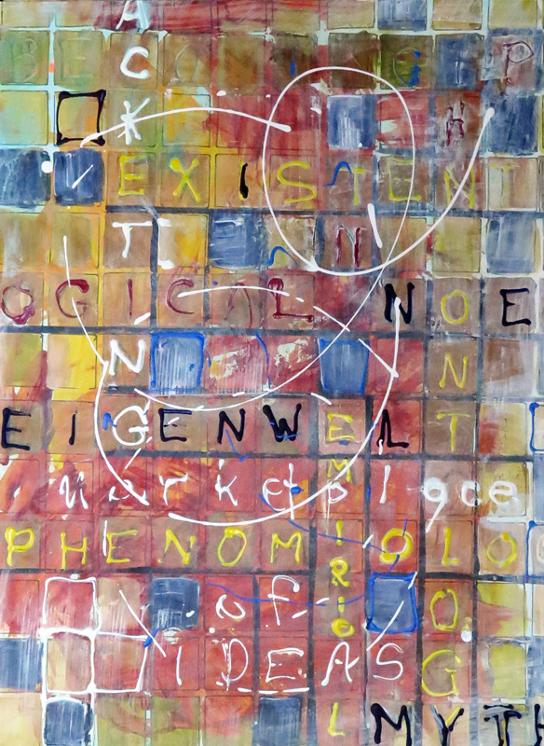

Marketplace of Ideas.
Acrylic on rag paper, 30x22 inches

This piece creates an overview of the entire exhibition, given that each of the crosswords plays with a specific idea and suggests the multiplicity of theories, thoughts, buzzwords and cultural expressions floating throughout our collective consciousness.
Drawing on a cultural studies background, I revisited some of the writings and ideas of the French feminist scholars that influenced feminist theory when they were translated into English in the 1970s.
With help from wikipedia.org

Cixous
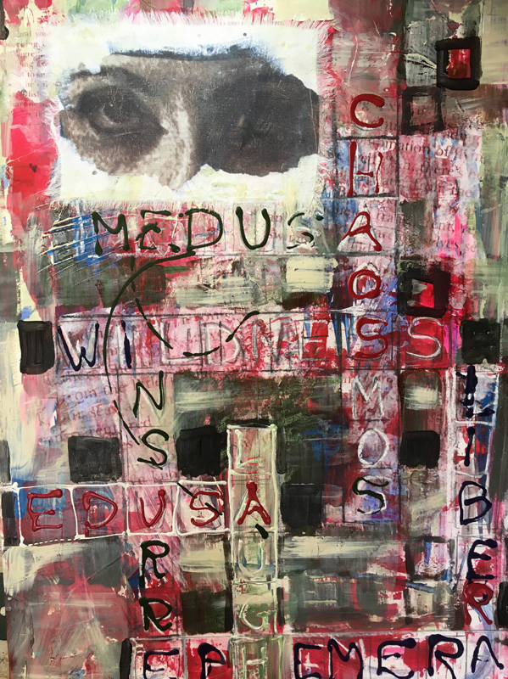
Hélène Cixous is a professor, French feminist writer, poet, playwright, philosopher, literary critic and rhetorician. Her famous article "The Laugh of the Medusa" and her phrase “Write with your body” has inspired artists and writers for generations.
She is considered one of the early thinkers in post-structural feminism, and she founded the first centre of feminist studies at a European (today's University of Paris VIII).

The Laugh of the Medusa Hélène Cixous; Keith Cohen; Paula Cohen Signs, Vol. 1, No. 4. (Summer, 1976), pp. 875-893.

Julia
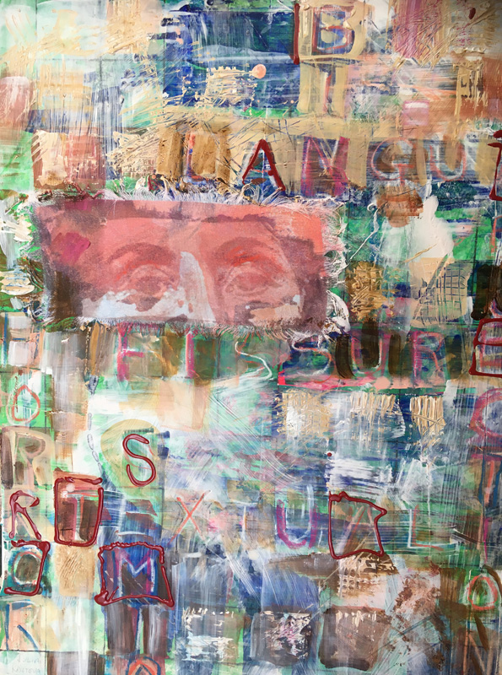
Julia Kristeva is a Bulgarian-French philosopher, literary critic, semiotician, psychoanalyst, feminist, and, most recently, novelist, who has lived in France since the mid-1960s. She is now a professor emerita at the University Paris Diderot. The author of more than 30 books, including Powers of Horror, Tales of Love, Black Sun: Depression and Melancholia, Proust and the Sense of Time, and the trilogy Female Genius, she has been awarded Commander of the Legion of Honor, Commander of the Order of Merit, the Holberg International Memorial Prize, the Hannah Arendt Prize, and the Vision 97 Foundation Prize, awarded by the Havel Foundation.

Kristeva became influential in international critical analysis, cultural studies and feminism after publishing her first book, Semeiotikè, in 1969. Her sizeable body of work includes books and essays which address intertextuality, the semiotic, and abjection, in the fields of linguistics, literary theory and criticism, psychoanalysis, biography and autobiography, political and cultural analysis, art and art history. She is prominent in structuralist and poststructuralist thought. Kristeva is also the founder of the Simone de Beauvoir Prize committee.
Luce
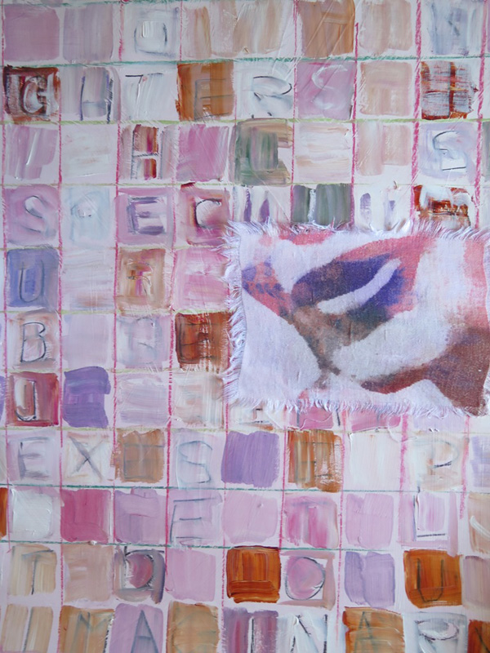
Luce Irigaray, (born 1932?, Belgium), French linguist, psychoanalyst, and feminist philosopher who examined the uses and misuses of language in relation to women. She received a doctorate in linguistics in 1968 from the University of Paris VIII. In the 1960s she trained as a psychoanalyst at the Freudian School of Paris, founded in 1964 by the philosopher and psychoanalyst Jacques Lacan. The publication of her second doctoral thesis (in philosophy), Speculum of the Other Woman, was highly critical of Freudian and Lacanian psychoanalysis, and resulted in her dismissal from her teaching positions. From 1964 Irigaray held a research position at the National Centre for Scientific Research in Paris. As of October 2021, she is active in the Women's Movements in both France and Italy.
Simone
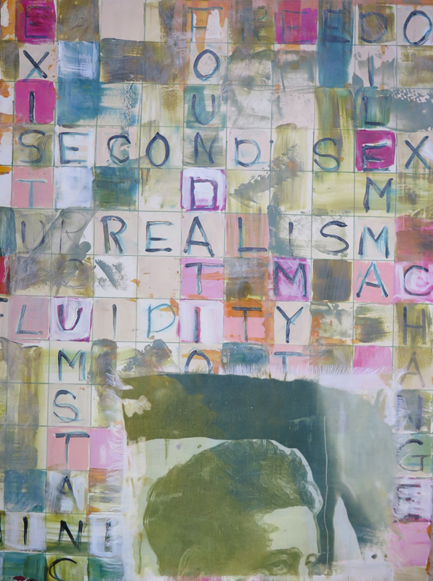
Simone Lucie Ernestine Marie Bertrand de Beauvoir 1908 –1986 was a French writer, intellectual, existentialist philosopher, political activist, feminist, and social theorist. She had a significant influence on both feminist existentialism and feminist theory.
Simone Lucie Ernestine Marie Bertrand de Beauvoir 1908 –1986 was a French writer, intellectual, existentialist philosopher, political activist, feminist, and social theorist. She had a significant influence on both feminist existentialism and feminist theory.
Beauvoir wrote novels, essays, biographies, autobiographies and monographs on philosophy, politics, and social issues. She was known for her 1949 treatise The Second Sex, a detailed analysis of women's oppression and a foundational tract of contemporary feminism; and for her novels, including She Came to Stay and The Mandarins. Her memoirs have a warmth and descriptive power. She won the 1954 Prix Goncourt, the 1975 Jerusalem Prize, and the 1978 Austrian State Prize for European Literature. She was also known for her open, lifelong relationship with French philosopher Jean-Paul Sartre.
CLIMATE
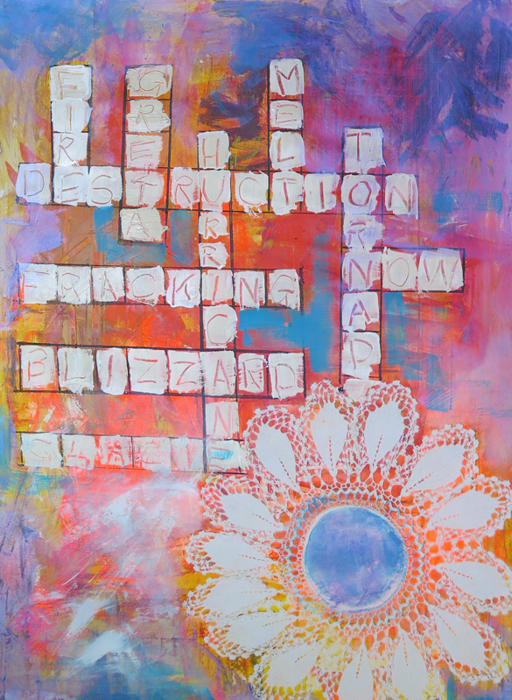
This is one of the earliest pieces in the series, presenting a few words that continually appear in reports of disasters around the globe. The sun is represented by a fabulously crocheted doily incorporated into the painting. The cheerful colours and perky fabric inclusion offers an ironic counterpoint to the dire words.

VIRUS
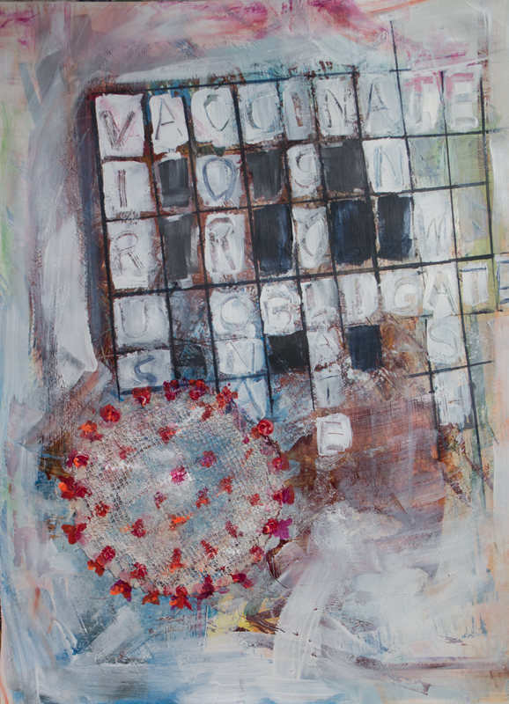
The first crossword I made takes a piece of handwork and transforms it into the corona virus image. Just as my lockdown time was spent creating this series, the time consuming needlework would have given women something to do during long hours in circumscribed lives. The words I used are still some of the more significant words in our language today.

MONEY
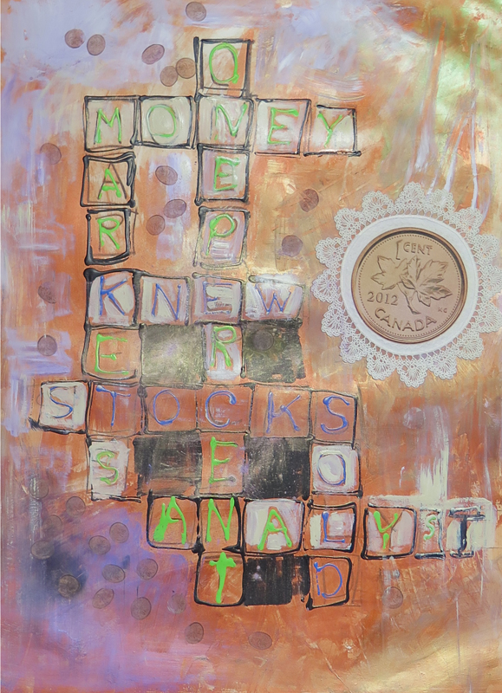
Who gains? Who loses? Our extinct copper penny becomes the visual hook against a few bits of text from the financial pages. A cotton doily holds the image, which then is incorporated into an acrylic background.

JUST DON’T
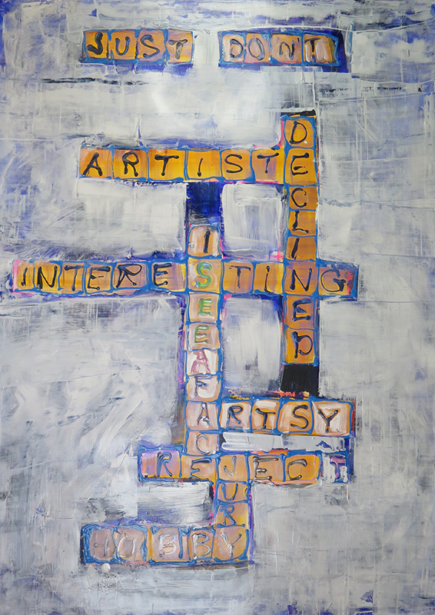
My Facebook request for phrases that artists hate to hear, or to be described as, had huge response. Here were some of my favourites.

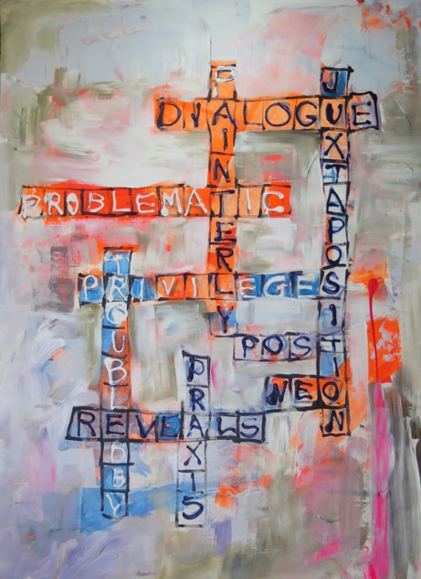
JARGON

This is the result of another request on facebook for words from art writing that artists and writers find to be overused, pretentious, and otherwise annoying.
I learned that I have probably used all of them in my own essays and reviews.
Problematic indeed!

CLEISTHENES, the father of democracy
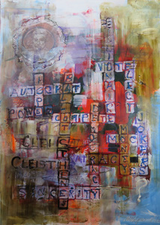
So that’s his bust and a cherry picking of words connected to the idea of democracy. The cotton handiwork here contains an overpainted, somewhat abused version of his image.
While I painted this long before January 6, democracy was already an idea in jeopardy in many places.
Cleisthenes was an ancient Athenian lawgiver credited with reforming the constitution of ancient Athens and setting it on a democratic footing in 508 BC. He was also credited with increasing the power of the Athenian citizens' assembly and for reducing the power of the nobility over Athenian politics.
Through Cleisthenes' reforms, the people of Athens endowed their city with isonomic institutions—equal rights for all citizens (though only free men were citizens)—and established ostracism as a punishment.
He also established sortition – the random selection of citizens to fill government positions rather than kinship or heredity, a true test of real democracy.
PSYCH 101
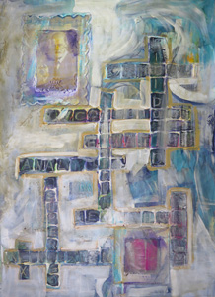
Freud and Jung in their corners and pop culture words pulled from general knowledge of their ideas.
Their images, dyed into frames, are painted across in a manner that suggests a level of corruption in understanding of the concepts they explored and developed.

JUNK
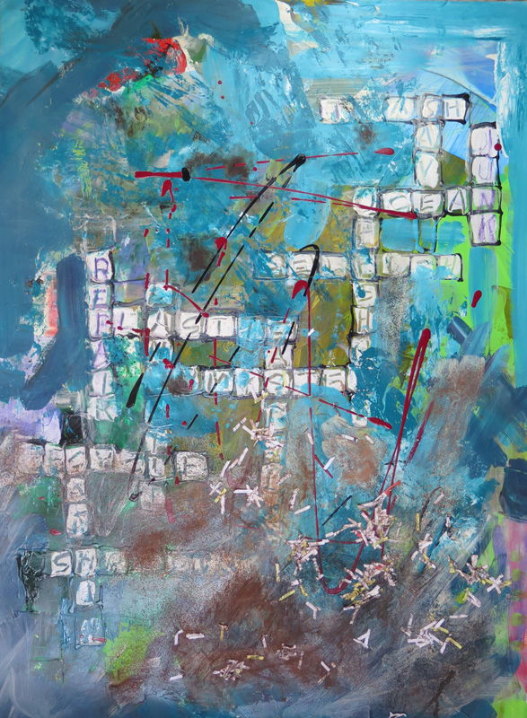
A messy and fractious expression intended to impart a chaotic situation The Great Pacific Garbage Patch is a collection of marine debris in the North Pacific Ocean.
The Great Pacific Garbage Patch, also known as the Pacific trash vortex, spans waters from the West Coast of North America to Japan. The patch is actually comprised of the Western Garbage Patch, located near Japan, and the Eastern Garbage Patch, located between the U.S. states of Hawaii and California.
While oceanographers and climatologists predicted the existence of the Great Pacific Garbage Patch, it was a racing boat captain by the name of Charles Moore who actually discovered the trash vortex. Moore was sailing from Hawaii to California after competing in a yachting race. Crossing the North Pacific Subtropical Gyre, Moore and his crew noticed millions of pieces of plastic surrounding his ship.
https://www.nationalgeographic.org/encyclopedia/great-pacific-garbage-patch/

